 VIT
U N I V E R S I T Y
(Estd. u/s 3 of UGC Act 1956)
Vellore – 632 014, Tamil Nadu, India
School of Information Technology and Engineering

Programme : MS [SE] – II Sem
Subject : Object Oriented Programming with C++

Cycle Sheet – II

- Write a program to find the area and perimeter of triangle, rectangle and square using function overloading .
- Define a C++ structure called Nokia with the following members.
i) A long integer member to store the Mobile model.
ii) A float member to store the Price.
iii) A integer member to store the Demand level.
Write a C++ program
i) To read the details of six Mobile model using an array variable.
ii) To sort the list based on the price of the mobile and display the
sorted list.
iii) To sort the list based on the demand level and display the sorted
list
- Write a program to get the details of student and display it using class and object.
- Define a class named TaxReturn that contains a taxID number, last name, first name, annual income, number of dependents and amount of tax owed for a taxpayer. Include constant static fields that holds the tax rates for the situations shown in the following table

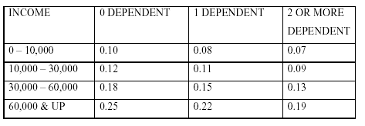
Include a static function that displays the tax table. Write a main function
that contains a single statement that displays the tax table in C++.

- Develop an object oriented program in C++ to read the following information from the standard input device. Employee name, Employee code, Designation, Date of Joining (format mm/dd/yy—with date checking) & Age.

Carry out the following operations (Use arrays).
  - Display the Employee detail table with minimum 3 records.
  - Insert a new Employee into the table
  - Delete an entry from the table
  - Edit an entry
  - Search for a record based on employee code and print the details.

- Create a Bank_Account class with private data members account_no, name, address and type of account. Account number should be unique.
i) Create member functions to enter the details of 5 account holders.
ii) Search for an account based on an account number
iii) Delete an account number.

- Create a class Bank_Atm with private data members initial_balance, current_balance, name, account number.
i) initiliase initial_balance to 1500 using constructor.
ii) Get the details from the user for 3 users using arrays,
iii)Use functions for deposit, withdrawal and displaying details.

- Write a class Gravitas Event Registration with private data members event_name, event_id, event_date, prize_amount. Maximum prize amount is 40K. Create the events such that the maximum prize amount doesn’t exceed 40 K. If it exceeds that amount display error message.

i) Get the input from the user or use constructors.
ii) Sort based on the event_date.

